Exercise Solution

Task – 01
Describe the behavior of the half adder in your own words.

Behavior of the Half Adder
A half adder is a simple digital circuit that adds two single-bit binary numbers. It has two inputs, typically labeled A and B, and produces two outputs: the Sum and the Carry. The Sum output represents the direct sum of the input bits, while the Carry output indicates if there was an overflow (i.e., if both input bits were 1, leading to a carry to the next higher bit position).
- If A and B are both 0, the Sum is 0 and the Carry is 0.
- If A is 1 and B is 0 (or vice versa), the Sum is 1 and the Carry is 0.
- If both A and B are 1, the Sum is 0 and the Carry is 1.
Task – 02
Explain why the Sum output uses an XOR gate, and the Carry output uses an AND gate.

Using XOR for Sum and AND for Carry
- Sum Output (XOR Gate): The XOR (exclusive OR) gate is used because it outputs a 1 only when the two inputs are different. This behavior aligns with how the Sum output should behave in binary addition
  - A=0,B=0 → Sum = 0
  - A=1,B=0 → Sum = 1
  - A=0,B=1 → Sum = 1
  - A=1,B=1 → Sum = 0
- Carry Output (AND Gate): The AND gate is used for the Carry output because it outputs a 1 only when both inputs are 1. This matches the behavior required to produce a carry in binary addition (only when both bits are 1)
  - A=1,B=1 → Carry = 1
  - In all other cases, the Carry is 0.
Task-03
Modify the circuit: What changes would you make to create a full adder using two half adders and an additional OR gate?

Half Adder:

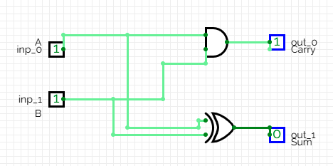

Full Adder using half adder :

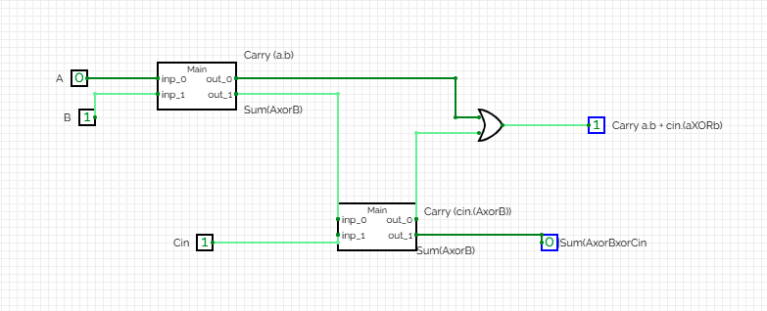

Task-04
Explain a real-world application of half adders in digital systems.

Half adders are fundamental building blocks in digital electronics, especially in arithmetic circuits like binary addition. One practical example is their use in calculators or computer arithmetic logic units (ALUs) for basic operations. Although a half adder alone can't handle multi-bit numbers (as it lacks a Carry-In input), it is used to construct full adders, which form the basis for adding multi-bit binary numbers in digital devices. These adders are integral to operations like address calculations, data transfers, and more complex functions in modern processors.

